6 High-Level Design (Architecture)
Chapter 8. The rule now reverses: a high-level design that does not say where things run, what they are built from and what that choice cost has not been done.
6.1 Architectural drivers: quality-attribute scenarios
QAS | Quality  attribute | Stimulus | Artifact | Response | Response  measure | From
QAS-01 | Performance | Search of a database with no more than 500 records | Search engine + renderer | Returns matching locations to the interface | Within 2 seconds for 95% of 50 test searches | QR-1
QAS-02 | Usability | Using a 360px and 1280px viewport | UI Engine and viewport controller | Adjusts dynamically to fit the dimensions | UI elements remain usable without horizontal scrolling | QR-3
QAS-03 | Reliability | An empty/invalid string is used for the search query | Input validation/error handling | Catches and updates the UI to reflect | Display a message with zero unhandled errors across 20 tests | QR

Our project has only one constraint relevant to high-level design: CON-03, where the team is only allowed to use data/information it has permission to access, redistribute, and display.
6.2 Architectural style and alternatives
Style considered | Drivers it serves | What it costs | Verdict
Single Page Web Application | Performance, Usability, accessibility | Reliance on network connection | Chosen
Desktop Application | High compute speed for geospatial calculations, no network connection needed | Requires manual installation | Rejected
Static HTML | Low cost hosting and high availability | Cannot support dynamic/real time features | Rejected

We chose a single page web application architecture because it fulfills drivers QAS-01 and QAS-02 the best. It fulfills QAS-01 by offloading the query to a server, and it fulfills QAS-02 by rendering the application window locally. We rejected a layered desktop application because it is not accessible: manual installation is a high up-front cost to the user. We also rejected a static website since it restricts the type of features we could possibly add. We will call this ADR-01.
6.3 Component view
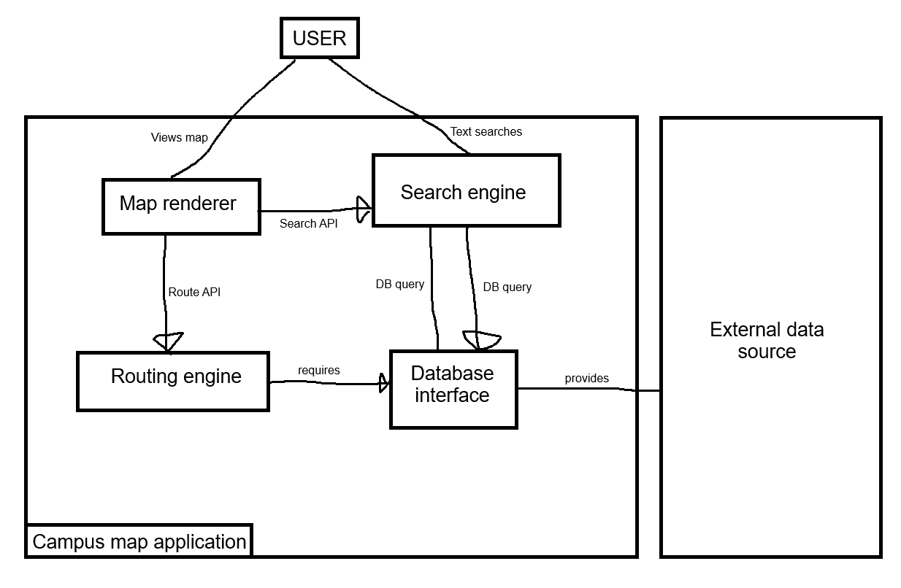

Figure 6.3 Component diagram: components, provided and required interfaces, external systems
Component | Responsibility (one sentence) | Provides | Requires | Answers to (UC / QAS / ADR)
Map renderer | Manages client viewport and user interactions | Map display | Route API, Search API | UC-01, UC-02, UC-03 UC-04, QAS-02, ADR-01
Search engine | Provides user with data based on an inputted query | Search API | DB Query | UC-01, UC-03, QAS-01, ADR-01
Routing engine | Calculates optimal route between locations | Route API | DB Query | UC-02, QAS-01
Database interface | Retrieves data from external data source | DB Query | None | UC-04

6.4 Deployment view
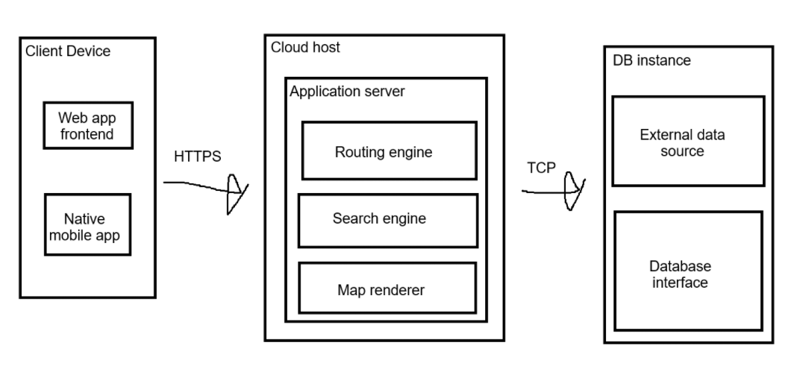

Figure 6.4 UML deployment diagram: nodes, execution environments, deployed artifacts, communication paths with protocols, trust boundaries
Node | What runs on it (artifacts,  components) | Communicates with  (protocol) | Trust zone
Client device | Web browser/mobile app | HTTPS | Public internet (untrustworthy)
Could host | Routing engine, search engine, map renderer | TCP | Secure application
DB Instance | External data source, DB interface | Cloud application server | Private database (full trust)

6.5 From analysis to architecture
Analysis object (from 5.1 and 5.2) | Component that owns it (6.3) | Note (split, merged, external)

GUIDANCE: DELETE THIS BOX BEFORE SUBMITTING
Every class and interaction object from section 5 lands in exactly one component, or the note says why it was split, merged or left to an external system. This table is how the reader sees that the architecture realizes the analysis rather than replacing it. Budget: a quarter of a page.
CS 3354 · P2 Analysis and High-Level Design · Template | Page 14
CE/CS/SE 3354 · Software Engineering · Fall 2026
6.6 Design principles applied
Principle | Where it shows in your design | Evidence (component,  interface, ADR)
Separation of concerns | Splitting map rendering from routing and search logic | Map rendering UI vs. Search and Routing engine
Information hiding | Database is hidden behind a data interface | Data interface providing DBQuery interface
Low coupling | Independent backend services | SearchAPI and RouteAPI
High cohesion | Backend services focus on one task | Search engine and routing engine
Design for change | Isolated external data | External data source
Keep it simple (KISS) | Lightweight single page web application | ADR-01

